16 July 2026: Tranche 3 LGR Decisions
Contents
16 July 2026: Tranche 3 LGR Decisions 1
Summary 2
Derbyshire 4
Devon 6
East Sussex and Brighton 8
Gloucestershire 9
Hertfordshire 10
Kent 12
Lancashire 14
Leicestershire 16
Lincolnshire 18
Nottinghamshire 20
Oxfordshire and West Berkshire 22
Staffordshire 24
Warwickshire 26
Worcestershire 27
Appendix A – summary of council and councillor numbers 28
Appendix B – population numbers in new councils 30

Summary
All councils going through LGR have now received their final decisions, except for West Sussex, and Cambridgeshire and Peterborough.
The decisions made by the Secretary of State for Housing, Communities and Local Government are available at:
- Surrey (28 October 2025)
- Tranche 2 (25 March 2026)
- Tranche 3 (16 July 2026)
A full outline of decisions is at Appendix A.

Council numbers
The decisions taken to date mean a reduction from 190 councils to 56.
- In Cambridgeshire and Peterborough, if one of the existing proposals is taken forward, this will see a reduction from seven councils to two or three.
- In West Sussex, if one of the existing proposals is taken forward, this will see a reduction from eight councils to one or two.
This means that the total number of councils in England from 1 April 2028 will be 171-173, down from 317:
- 112 councils not engaged in LGR (excluding West Berkshire)
- 56 new councils already announced
- Between three and five more councils to be announced.
This is an increase in upper tier councils from 153.

Number of councillors
Currently the number of councillors for all areas going through LGR that have received decisions is 8,491.
The number of councillors in new authorities (using details in the original proposals) will be 4,080 – 4,198. This is a reduction of 50.6 per cent.

Population size of unitaries
- The average population size of the new unitaries proposed is approximately 414,363.
- The median population size of the new unitaries proposed is approximately 373,664
For comparative purposes:
- the average population size of a London borough is approximately 284,000 residents
- the largest unitary council in England, by population size, is Birmingham City Council which serves approximately 1.18 million residents
- recent reorganisations include North Yorkshire (619,000), Cumberland (273,000) and Westmorland and Furness (228,187).

Decisions taken on 16 July 2026
The number of unitaries for each area as a result of decisions made by the Secretary of State on 16 July 2026 are as follows:
- Derbyshire - 2
- Devon - 4
- East Sussex - 2
- Gloucestershire - 1
- Hertfordshire - 4
- Kent - 4
- Lancashire - 4
- Leicestershire - 2
- Lincolnshire - 4
- Nottinghamshire - 2
- Oxfordshire and West Berkshire - 3
- Staffordshire - 2
- Warwickshire - 2
- Worcestershire - 2
Along with these decisions, the Secretary of State also announced:
- Re-confirmation of £900,000 per new unitary authority to support transition costs
- Up to £150,000 per each new unitary as supplementary funding for leadership capacity and continuity in children’s services, adult social care and public health, along with wider support in these areas for targeted development, mentoring and peer support for current, new and aspiring leaders
- Up to £1 million of funding to support areas with complex fire and rescue authority transitions
- Commitment to the existing timetable for all areas, with elections to new unitaries on 6 May 2027, and vesting day on 1 April 2028.

Derbyshire
Current number of councils: 10 (one county, one unitary, eight districts)
Current number of councillors: 447
The 2 unitary proposal (“option B1”) has been taken forward. This proposal includes boundary changes using the geographies of different parish councils within Amber Valley borough as the building blocks for the proposed configuration of the two new unitary councils, with more of Amber Valley borough’s population falling under the remit of the southern Derbyshire unitary council.
New council | Population
Northern Derbyshire | 539,000
Southern Derbyshire | 538,000

This proposal suggests there will be 162 councillors for Derbyshire. This is a reduction of 285.
This proposal was supported by the following councils:
- Chesterfield Borough Council
- Derby City Council
- Erewash Borough Council
- High Peak Borough Council
This proposal was not supported by the following councils:
- Amber Valley Borough Council
- Bolsover District Council
- Derbyshire County Council
- Derbyshire Dales District Council
- North East Derbyshire District Council
- South Derbyshire District Council
See the full proposal here: Appendix 3.4 - Case for Change: Proposal B1
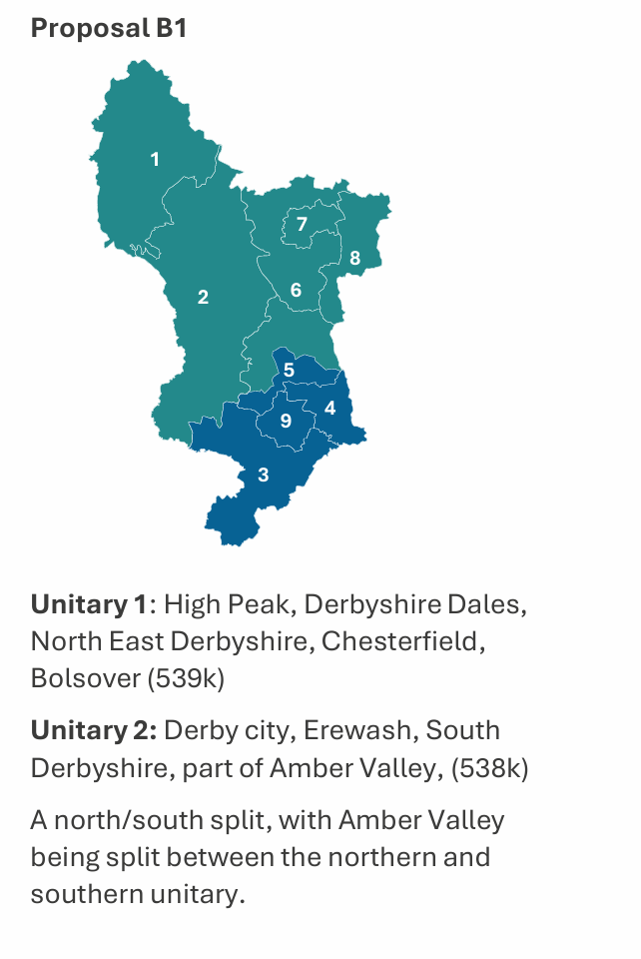

Devon
Current number of councils: 11 (one county, two unitaries, eight districts)
Current number of councillors: 481
The four unitary proposal (“Four unitaries (A)”) has been taken forward. This proposal includes boundary changes, including an expanded Plymouth, expanded Exeter, expanded Torbay, and a new Devon Coast and Countryside authority, using parish-based changes.
New council | Population
Devon Coast and Countryside | 260,195
Exeter | 455,883
Plymouth | 305,731
Torbay | 232,697

This proposal suggests there will be between 246-298 councillors for Devon. This is a reduction of between 183-235 councillors.
This proposal was supported by the following councils:
- Exeter City Council
- Plymouth City Council
This proposal was not supported by the following councils:
- Devon County Council
- East Devon District Council
- Mid Devon District Council
- North Devon Council
- South Hams District Council
- Teignbridge District Council
- Torbay Council
- Torridge District Council
- West Devon Borough Council

See the full proposal here: Plymouth Exeter LGR joint submission summary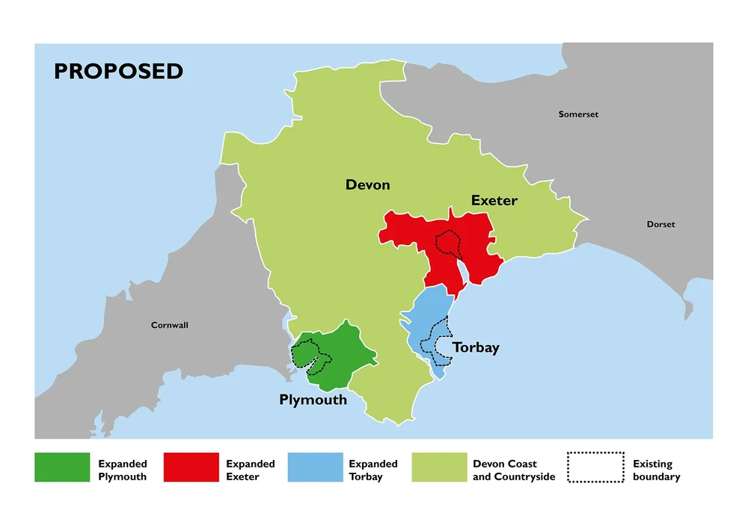

East Sussex and Brighton
Current number of councils: 7 (one county, one unitary, five districts)
Current number of councillors: 287
The two unitary proposal has been taken forward. This proposal includes boundary changes that expand Brighton and Hove into parts of Lewes.
New council | Population
East Sussex | Approx. 537,000
Brighton and Hove | Approx. 308,000

This proposal suggests there will be 154 councillors for East Sussex and Brighton. This is a reduction of 133.
This proposal is a modification of the proposal initially put forward by all councils in East Sussex, which included two unitary councils on the existing boundaries of East Sussex and Brighton and Hove.
Brighton and Hove council requested a modification of that proposal to incorporate a number of wards and parishes from Lewes.
This modification has been accepted, except for the parish of Falmer which will remain in East Sussex.
See the full, unmodified proposal here: One East Sussex Proposal
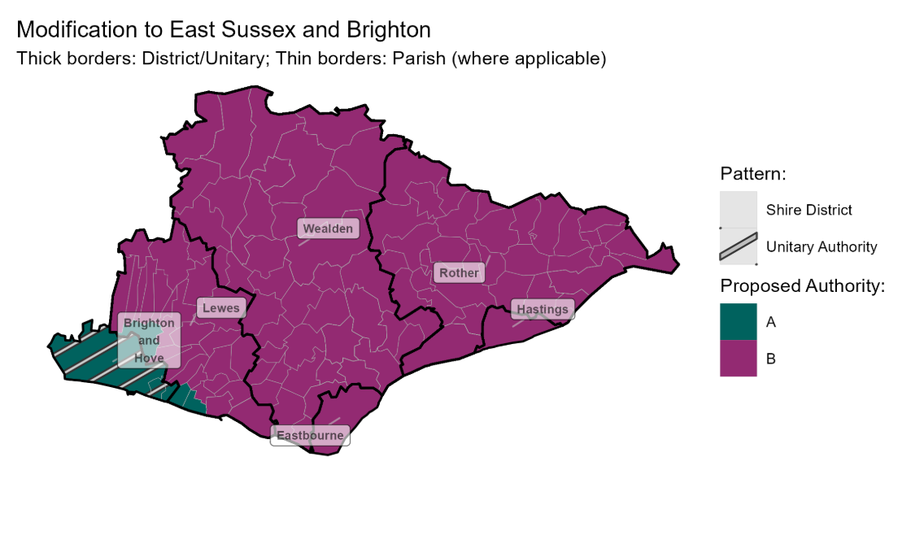

Gloucestershire
Current number of councils: 7 (one county, six districts)
Current number of councillors: 295
The single unitary proposal (“1UA”) has been taken forward. This proposal does not include boundary changes.
New council | Population
Gloucestershire | 659,000

This proposal suggests there will be 110 councillors for Gloucestershire. This is a reduction of 185.
This proposal was supported by the following councils:
- Cotswold District Council
- Gloucestershire County Council
- Stroud District Council
- Tewkesbury Borough Council
This proposal was not supported by the following councils:
- Cheltenham Borough Council
- Forest of Dean District Council
- Gloucester City Council
See the full proposal here: 1UA-Proposal-Gloucestershire-Local-Government-Reorganisation.pdf
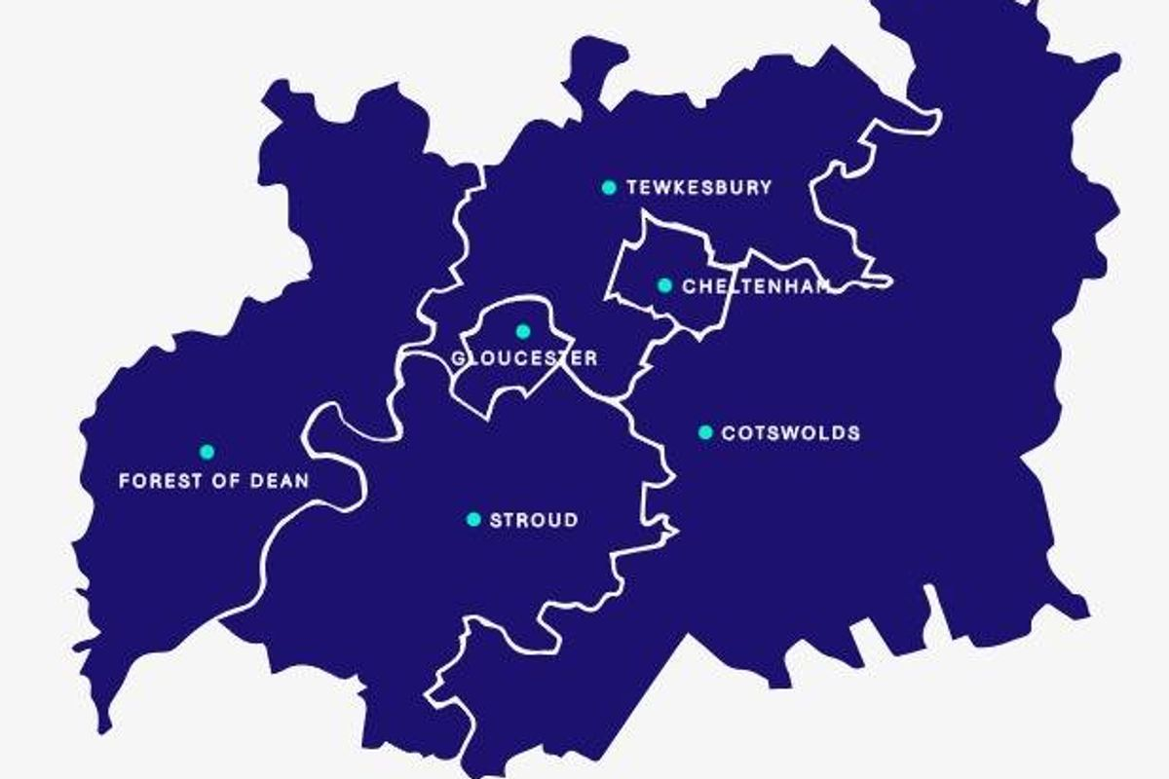

Hertfordshire
Current number of councils: 11 (one county, ten districts)
Current number of councillors: 517
The four unitary proposal (“option C”) has been taken forward. This proposal includes boundary changes, which would move the Royston area from North Herts and Northaw & Cuffley from Welwyn Hatfield into the proposed Eastern Hertfordshire unitary authority.
New council | Population
North West Hertfordshire | 312,432
South West Hertfordshire | 313,190
Central Hertfordshire | 320,795
Eastern Hertfordshire | 289,774

This proposal suggests there will be 327 councillors for Hertfordshire. This is a reduction of 190.
This proposal was supported by the following councils:
- Broxbourne Borough Council
- Hertsmere Borough Council
- Dacorum Borough Council
- North Herts Council
- Stevenage Borough Council
- Welwyn Hatfield Borough Council
This proposal was not supported by the following councils:
- East Hertfordshire District Council
- Hertfordshire County Council
- St Albans City and District Council
- Three Rivers District Council
- Watford Borough Council

See the full proposal here.

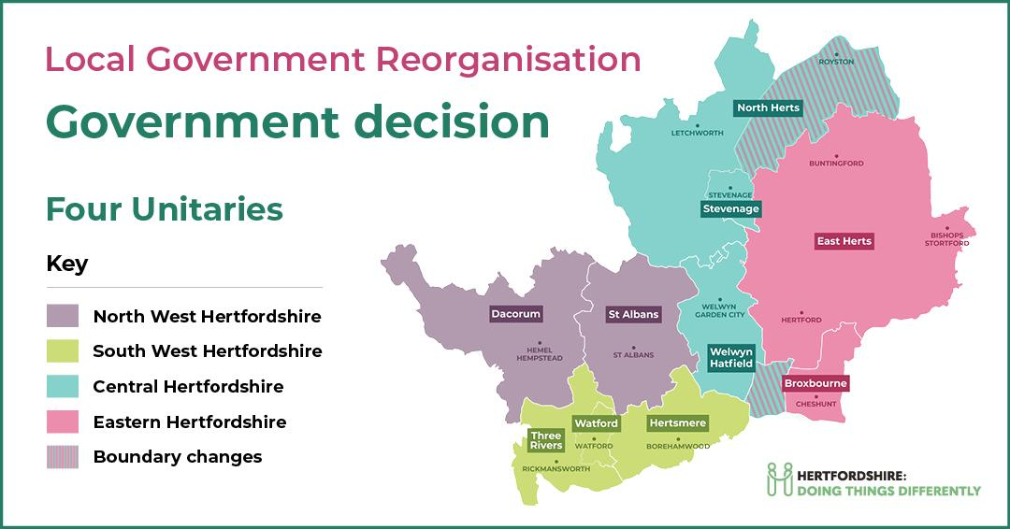

Kent
Current number of councils: 14 (one county, one unitary, twelve districts)
Current number of councillors: 658
A 4 unitary proposal (“option 4b”) has been taken forward. This proposal does not include boundary changes.
New council | Population
North Kent | 528,337
West Kent | 567,062
East Kent | 424,559
Mid Kent | 411,726

This proposal suggests there will be 291 councillors for Kent. This is a reduction of 367.
This proposal was supported by the following councils:
- Dover District Council
- Swale Borough Council
- Thanet District Council
This proposal was not supported by the following councils:
- Ashford Borough Council
- Canterbury City Council
- Dartford Borough Council
- Folkestone and Hythe District Council
- Gravesham Borough Council
- Kent County Council
- Maidstone Borough Council
- Medway Council
- Sevenoaks District Council
- Tonbridge and Malling Borough Council
- Tunbridge Wells Borough Council

See the full proposal here: Kent-Local-Government-Reorganisation-Business-Case-Option-4B.pdf
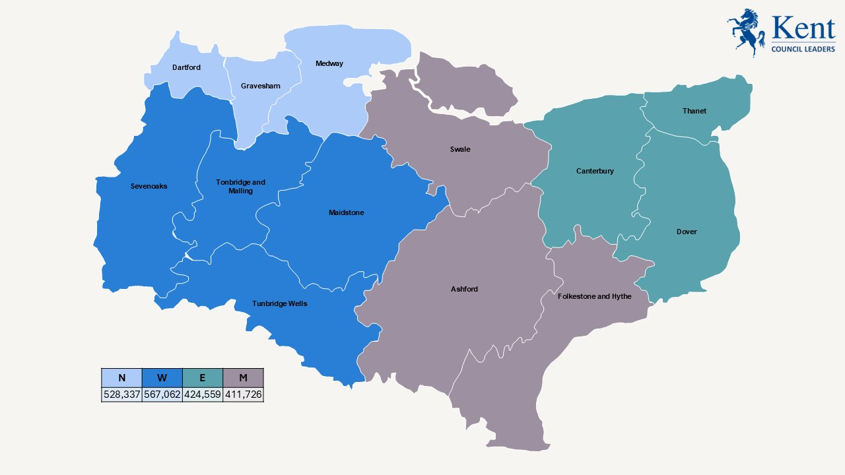

Lancashire
Current number of councils: 15 (one county, two unitaries, twelve districts)
Current number of councillors: 693
The four-unitary proposal has been taken forward. This proposal does not include boundary changes.
New council | Population
North Lancashire | 373,664
East Lancashire | 520,653
South Lancashire | 358,947
West Lancashire | 348,281

This proposal suggests there will be 296 councillors for Lancashire. This is a reduction of 397.
This proposal was supported by the following councils:
- Chorley Council
- Lancaster City Council
- Preston City Council
- Ribble Valley Borough Council
- South Ribble Borough Council
- West Lancashire Borough Council
This proposal was not supported by the following councils:
- Blackburn with Darwen Borough Council
- Blackpool Council
- Burnley Borough Council
- Fylde Council
- Hyndburn Borough Council
- Lancashire County Council
- Pendle Borough Council
- Rossendale Borough Council
- Wyre Council

See the full proposal here: four-lancashire-proposal-document
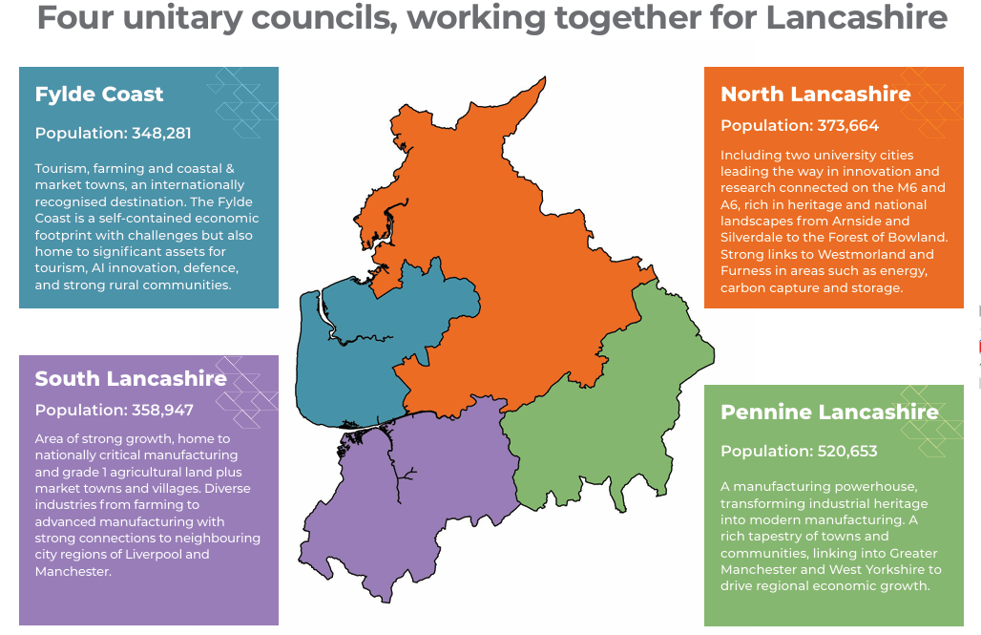

Leicestershire
Current number of councils: 10 (one county, two unitaries, seven districts)
Current number of councillors: 384
The two unitary proposal (“Option 1 - preferred”) has been taken forward. This proposal includes boundary changes, with one of the unitary councils comprising an expanded Leicester City (indicated on map below).
New council | Population
Greater Leicester | 622,000
Leicestershire | 584,000

This proposal suggests there will be between 141-170 councillors for Leicestershire. This is a reduction of between 214-243 councillors.
This proposal was supported by the following councils:
- Leicester City Council
This proposal was not supported by the following councils:
- Leicestershire County Council
- Blaby District Council
- Charnwood Borough Council
- Harborough District Council
- Hinckley and Bosworth Borough Council
- Melton Borough Council
- North West Leicestershire District Council
- Oadby and Wigston Borough Council
- Rutland County Council
See the full proposal here: MASTER - Leicester City Council final LGR submission main document
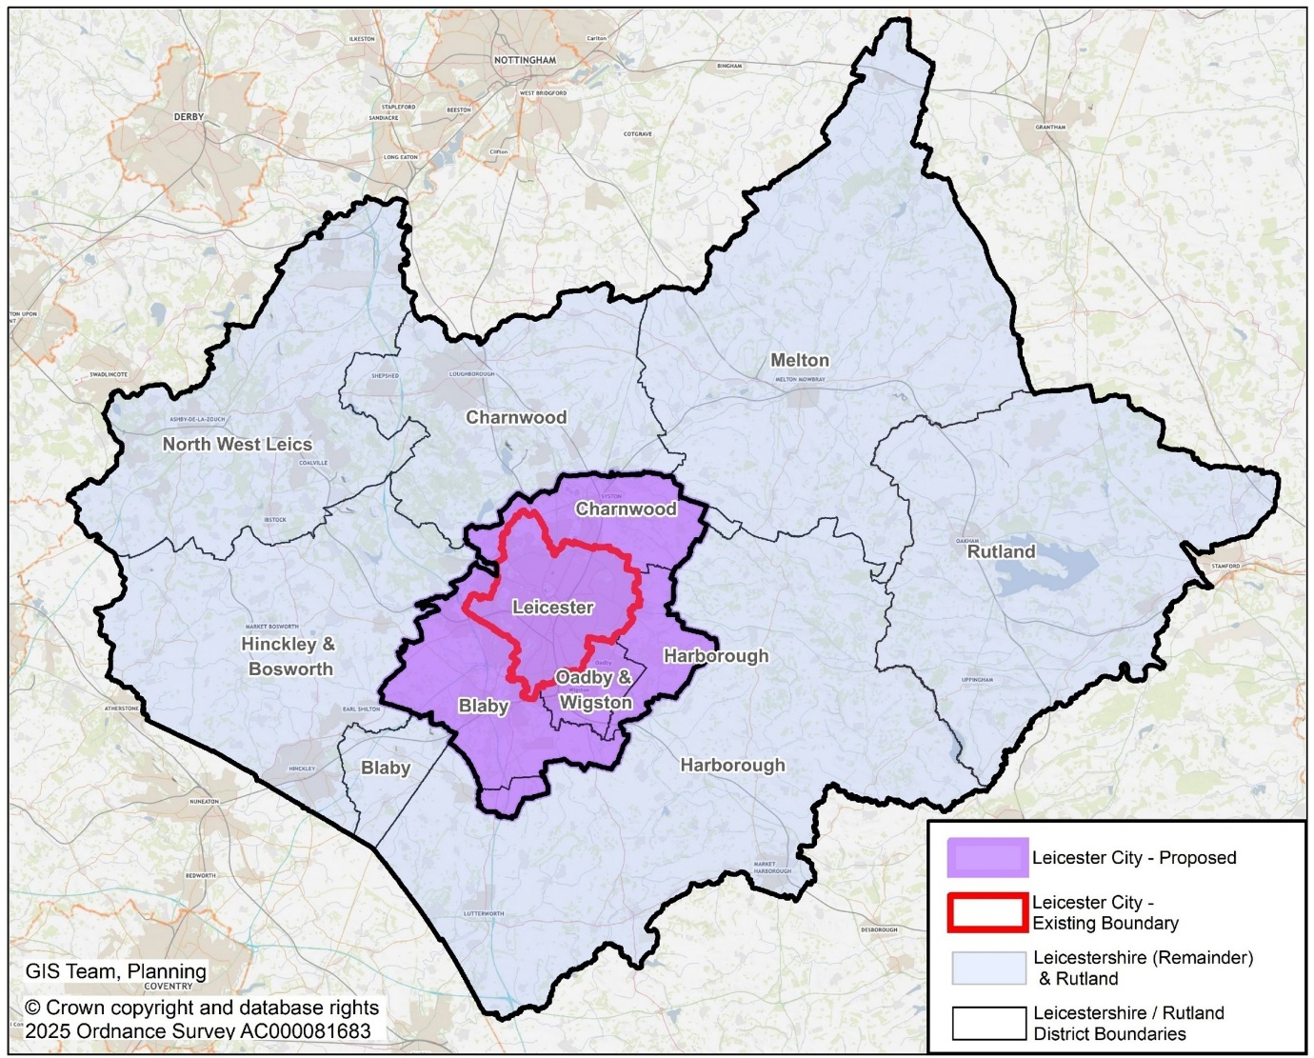

Lincolnshire
Current number of councils: 10 (one county, two unitaries, seven districts)
Current number of councillors: 445
A four unitary proposal has been taken forward. This proposal includes North Lincolnshire and North East Lincolnshire remaining as unitary authorities, and boundary changes to expand the City of Lincoln by incorporating parts of North Kesteven and West Lindsey.
New council | Population
Lincoln City | 224,839
Rural Lincolnshire | 617,931
North East Lincolnshire (existing council) | 159,911
North Lincolnshire (existing council) | 171,336

This proposal suggests there will be 221 councillors for Lincolnshire. This is a reduction of 224.
This proposal was supported by the following councils:
- Lincoln City Council
This proposal was not supported by the following councils:
- Boston Borough Council
- East Lindsey District Council
- Lincolnshire County Council
- North Kesteven District Council
- North East Lincolnshire Council
- North Lincolnshire Council
- South Holland District Council
- South Kesteven District Council
See the full proposal here: Local Government Reorganisation – City of Lincoln Council
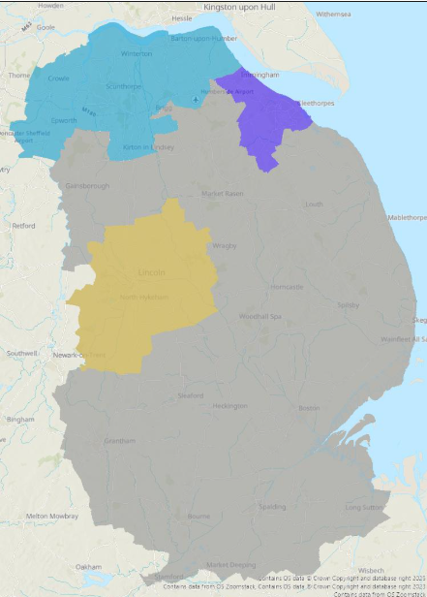

Nottinghamshire
Current number of councils: 9 (one county, one unitary, seven districts)
Current number of councillors: 408
A two unitary proposal (“option Bii”) has been taken forward. This proposal includes boundary changes, which will split Broxtowe, Gedling and Rushcliffe council areas to enlarge Nottingham City.
New council | Population
Southwest | 612,557
North and East | 561,213

This proposal suggests there will be 198 councillors for Nottinghamshire. This is a reduction of 210.
This proposal was supported by the following councils:
- Nottingham City Council
This proposal was not supported by the following councils:
- Ashfield District Council
- Bassetlaw District Council
- Broxtowe Borough Council
- Gedling Borough Council
- Mansfield District Council
- Newark and Sherwood District Council
- Nottinghamshire County Council
- Rushcliffe Borough Council
See the full proposal here:
- Executive summary
- Full submission
- Nottinghamshire LGR Hub
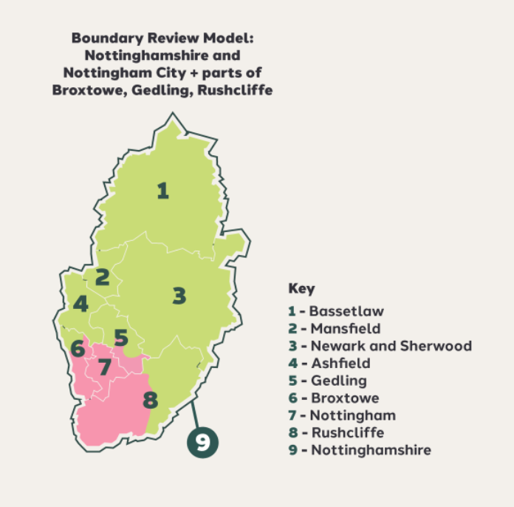

Oxfordshire and West Berkshire
Current number of councils: 6 (one county, five districts) PLUS West Berkshire
Current number of councillors: 288 in Oxfordshire PLUS 43 in West Berkshire
The three unitary proposal has been taken forward. This proposal includes boundary changes to expand Oxford City into parts of Cherwell and South Oxfordshire, and also incorporates West Berkshire council.
New council | Population
Greater Oxford | 241,000
Northern Oxfordshire | 265,000
Ridgeway | 429,000

This proposal suggests there will be 214 councillors for Oxfordshire and West Berkshire. This is a reduction of 117.
This proposal was supported by the following councils:
- Oxford City Council
This proposal was not supported by the following councils:
- Cherwell District Council
- Oxfordshire County Council
- South Oxfordshire District Council
- Vale of White Horse District Council
- West Oxfordshire District Council
- West Berkshire Council
See the full proposal here: Oxfordshire 3Councils Proposal
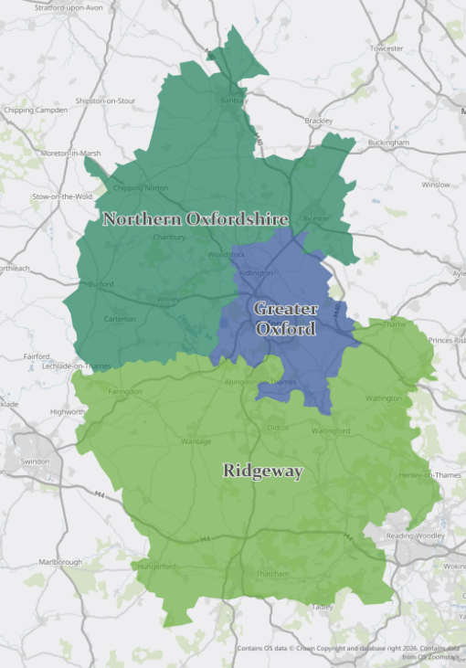

Staffordshire
Current number of councils: 10 (one county, one unitary, eight districts)
Current number of councillors: 438
A two unitary proposal has been taken forward. This proposal does not include boundary changes.
New council | Population
North Staffordshire | 494,803
South Staffordshire | 682,775

This proposal suggests there will be 176 councillors for Staffordshire. This is a reduction of 262.
This proposal was supported by the following councils:
- Cannock Chase District Council
- East Staffordshire Borough Council
- Stafford Borough Council
- Stoke on Trent City Council
This proposal was not supported by the following councils:
- Lichfield District Council
- Newcastle-under-Lyme Borough Council
- South Staffordshire District Council
- Staffordshire County Council
- Staffordshire Moorlands District Council
- Tamworth Borough Council
See the full proposal here:
- Executive summaries: northern council, southern council
- Full submissions: northern council, southern council
- Staffordshire LGR Hub
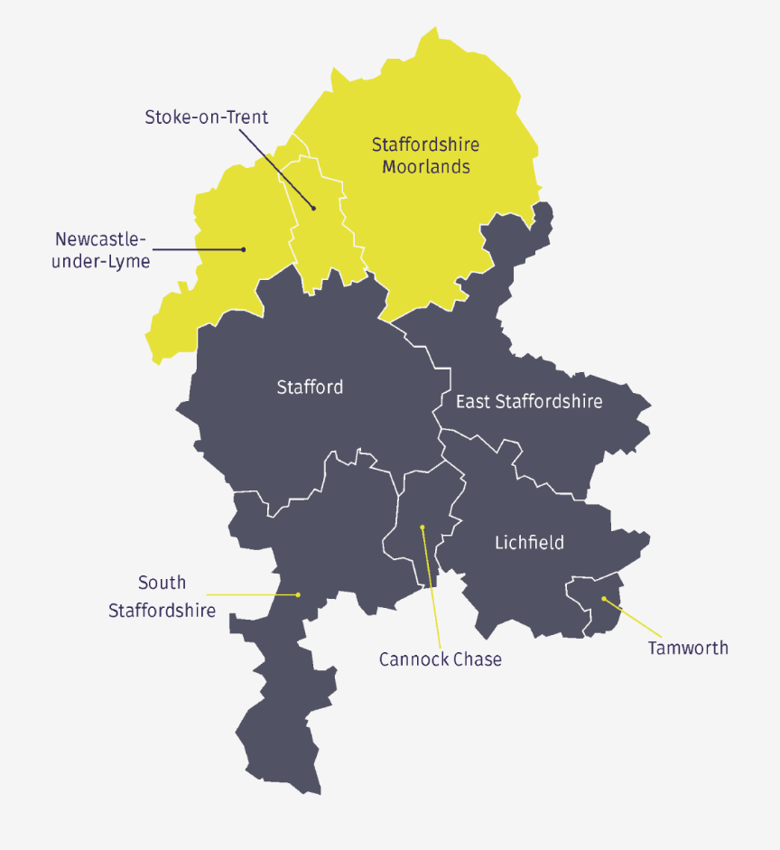

Warwickshire
Current number of councils: 6 (one county, five districts)
Current number of councillors: 257
The two unitary proposal has been taken forward. This proposal does not include boundary changes.
New council | Population
North Warwickshire | 322,741
South Warwickshire | 295,082

This proposal suggests there will be 121 councillors for Warwickshire. This is a reduction of 136.
This proposal was supported by the following councils:
- North Warwickshire Borough Council
- Nuneaton and Bedworth Borough Council
- Stratford-upon-Avon District Council
- Warwick District Council
This proposal was not supported by the following councils:
- Rugby Borough Council
- Warwickshire County Council
See the full proposal here: A Case for Two New Councils in Warwickshire
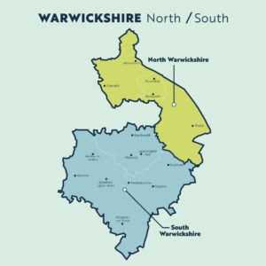

Worcestershire
Current number of councils: 7 (one county, six districts)
Current number of councillors: 257
The two unitary proposal has been taken forward. This proposal does not include boundary changes.
New council | Population
North Worcestershire | 293,445
South Worcestershire | 327,915

This proposal suggests there will be 114-133 councillors for Worcestershire (initially 114 based on existing county council divisions, with an expectation to increase numbers following Boundary Commission review). This is a reduction of 124-143.
This proposal was supported by the following councils:
- Bromsgrove District Council
- Malvern Hills District Council
- Redditch Borough Council
- Worcester City Council
- Wychavon District Council
This proposal was not supported by the following councils:
- Worcestershire County Council
- Wyre Forest District Council
See the full proposal here: Full submission
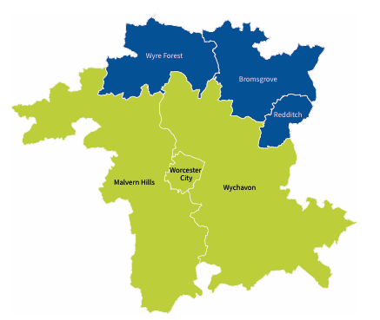

Appendix A – summary of council and councillor numbers
Area | Previous councils | New councils | Previous number of councillors | New number of councillors | Boundary changes?
Derbyshire | 10 (one county, one unitary, eight districts) | 2 | 447 | 162 | Yes
Devon | 11 (one county, two unitaries, eight districts) | 4 | 481 | 246-298 | Yes
East Sussex & Brighton | 7 (one county, one unitary, five districts) | 2 | 287 | 154 | Yes
Essex | 15 (one county, two unitaries, 12 districts) | 5 | 696 | 434 | No
Gloucestershire | 7 (one county, six districts) | 1 | 295 | 110 | No
Hampshire | 15 (one county, three unitaries, 11 districts) | 5 | 650 | 393 | Yes
Hertfordshire | 11 (one county, ten districts) | 4 | 517 | 327 | Yes
Kent | 14 (one county, one unitary, twelve districts) | 4 | 658 | 291 | No
Lancashire | 15 (one county, two unitaries, twelve districts) | 4 | 693 | 296 | No
Leicestershire | 10 (one county, two unitaries, seven districts) | 2 | 384 | 141-170 | Yes
Lincolnshire | 10 (one county, two unitaries, seven districts) | 4 | 445 | 221 | Yes
Norfolk | 8 (one county, seven districts) | 3 | 399 | 200 | Yes
Nottinghamshire | 9 (one county, one unitary, seven districts) | 2 | 408 | 198 | Yes
Oxfordshire | 6 (one county, five districts) PLUS West Berks unitary | 3 | 288 PLUS 43 | 214 | Yes
Staffordshire | 10 (one county, one unitary, eight districts) | 2 | 438 | 176 | No
Suffolk | 6 (one county, five districts) | 3 | 308 | 120-138 | Yes
Surrey | 12 (one county, 11 districts) | 2 | 540 | 162 | No
Warwickshire | 6 (one county, five districts) | 2 | 257 | 121 | No
Worcestershire | 7 (one county, six districts) | 2 | 257 | 114-133 | No
TOTAL | 190 | 56 | 8,491 | 4,080 – 4,198

Appendix B – population numbers in new councils
Estimated population size for all councils from Tranche 2 and Tranche 3. Please note that the Isle of Wight, North East Lincolnshire and North Lincolnshire have been excluded from the table below. These three existing unitaries will remain on the same footprint moving forward, and as particularly small unitaries, may have skewed the results in relation to new councils being established.
New council | Estimated Population
Lincoln City | 224839
Torbay | 232697
Greater Oxford | 241000
Ipswich and South Suffolk Council | 257000
Devon Coast and Countryside | 260195
Central and Eastern Suffolk Council | 261000
Northern Oxfordshire | 265000
Western Suffolk Council | 269000
Eastern Hertfordshire | 289774
Greater Norwich Council | 290000
North Worcestershire | 293445
South Warwickshire | 295082
Plymouth | 305731
Brighton and Hove | 308000
West Norfolk Council | 310000
North West Hertfordshire | 312432
South West Hertfordshire | 313190
Central Hertfordshire | 320795
North Warwickshire | 322741
South Worcestershire | 327915
West Essex | 331000
Mid Essex | 337000
East Norfolk Council | 341000
West Lancashire | 348281
South Lancashire | 358947
South East Essex | 366000
North Lancashire | 373664
South West Essex | 375000
North Hampshire | 402000
Mid Kent | 411726
East Kent | 424559
Ridgeway | 429000
Exeter | 455883
Mid Hampshire | 466000
South West Hampshire | 487000
North Staffordshire | 494803
East Lancashire | 520653
North East Essex | 521000
North Kent | 528337
East Sussex | 537000
Southern Derbyshire | 538000
Northern Derbyshire | 539000
East Surrey | 546000
North and East | 561213
South East Hampshire | 566000
West Kent | 567062
Leicestershire | 584000
Southwest | 612557
Rural Lincolnshire | 617931
Greater Leicester | 622000
West Surrey | 657000
Gloucestershire | 659000
South Staffordshire | 682775
Mean population size | 414363
Median population size | 373664

Excluded:
Isle of Wight | 146351
North East Lincolnshire (existing) | 159911
North Lincolnshire (existing) | 171336

