Toft Newton Parish Council
PO Box 1659
EPWORTH
North Lincolnshire
DN9 1UL
Tel: 07581 146213
E-mail: toftnewtonpc@outlook.com

4th of August 2025

West Lindsey District Council
Planning Department
Guildhall
Marshall’s Yard
Beaumont Street
GAINSBOROUGH
DN21 2NA

Dear Sir or Madam,

Ref: Planning Application WL/2025/00687

Proposal Details
Planning application for erection of a poultry farm comprising 6no. poultry houses and associated infrastructure.

Address
Land at Spridlington Road
Faldingworth
Market Rasen
LN8 3SQ

Parish
Faldingworth CP

Applicant Name
Stewart Adams

Toft Newton Parish Council being a neighbouring Parish Council to the location of this proposed development believe that we are duty bound to respond to this application, on behalf of our residents.

We object in the strongest possible manner to this proposal.

While every development within the district of West Lindsey will have some economic benefits to the district, the negative impacts of this development far outweigh the incredibly small positive effects this application is predicting

Our residents are concerned about this development on the grounds of the environmental, odour, noise and light pollution, transportation and infrastructure impacts and believe that it will have a significant impact on the quality of life of residents in the Toft Newton parish and of our closest neighbouring parishes of Faldingworth and Spridlington.

Mistakes:
As the Proper Officer at Toft Newton Parish Council, I am concerned by the number of mistakes contained within the application and supporting documentation, I therefore, have grave concerns about the validity and legality of this application.

Some of the mistakes are:
- Referring to West Lindsey District Council as East Lindsey District Council.
- Detailing 699 additional transportation movements, then referring to 714 per annum.
- Talking about 7.5 flocks per year, then elsewhere stating 7.6.
- Stating that there will be no runoff of waste water into the local waterways then detailing the technical specifications of such a water flow.
- Referring to 2.0 full time equivalent staff being employed on a daily basis, then elsewhere stating that it will be 2.0 full time equivalent and 1.0 part time staff members.

The simple mistakes point to a lack of attention to detail and give rise to concerns that the same lack of attention to detail would be embedded into the operating culture of Faldingworth Poultry Limited.

Location:
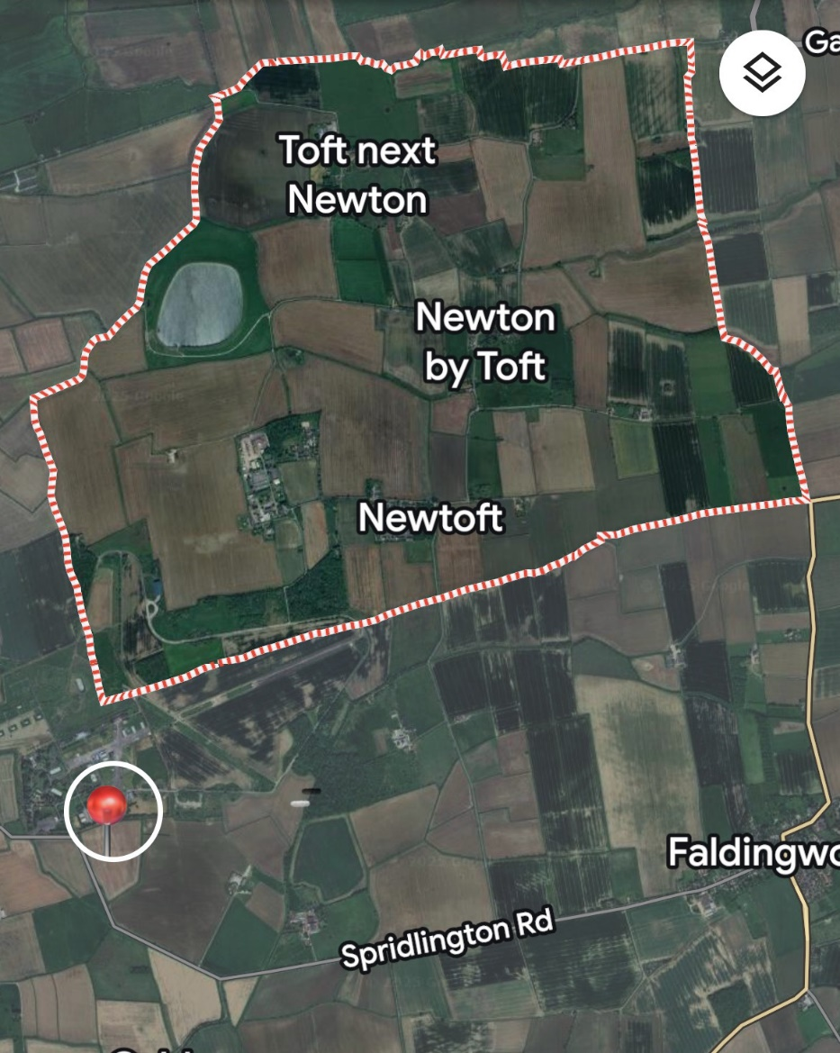
On the map opposite, I have dropped a pin on the proposed site, highlighted by a white circle, this shows how close the proposed site is to the Toft Newton parish boundaries.

The distance from the proposed site to Newtoft, the largest residential area in the Toft Newton parish is 2.0 kilometres (as the crow flies).

Despite being located at the point where the parish boundaries of Toft Newton, Spridlington and Faldingworth meet, Toft Newton has not been referenced in the planning application, which means the assessment and modelling does not include any impact (either negative or positive) that this development will have on the parish of Toft Newton, our residents and their quality of life.

We also note that the buildings, which are described as having a significantly negative visual impact will have a shelf life of more than 50 years and will be visible from the road, but also the Toft Newton parish.

Environmental:
2,936 tonnes of chicken manure annually will be removed in 44 tonnes / 16.5 meter articulated lorries, in sheeted trailers, not sealed units.

Manure collections will be on average every three days, meaning approximately 27 tonnes of manure to be collected and removed from the site each time.

The concrete apron and installation of multiple buildings with a concrete floor space in excess of 17,112.35m2, will significantly increase the risk of flooding on a site that is already a site at which flooding can occur.

The onsite attenuation pond will discharge collected rainwater into the local waterways once a year

The Barlings Eau River frequently floods, the Environment Agency includes Barlings Eau in their local Flood Alert service.

In 2024 and 2025, there has been localised flooding in the immediate vicinity / on this actual site.

Therefore, the Flood Risk and Drainage Assessment Report is significantly lacking in authenticity.

Concern has been raised by residents that the explosives that are tested at the neighbouring former Faldingworth Air Base will increase the number of chicken deaths, far beyond anything anticipated within the report - meaning that a site that is not expected to kill birds, will not be adequately prepared to deal with the large numbers of dead chickens.

We are concerned about the use of LPG Gas, as there is no natural gas supply in the area, five large gas storage tanks will be installed using 3,900,000 kWh per year of which only 50% will be generated from heat recovery systems meaning that 1,950,000 kWh will still need to be supplied to and stored on the site.

This is likely to result in annual Co2 emissions being increased by a minimum of 5,850,000kg per annum. We would expect the business to be paying a minimum of £0.025 per kg to offset their Co2 emissions and would therefore expect this to cost Faldingworth Poultry Limited a minimum of £146,250 per year, some of which should be invested in local community Co2 offset initiatives.

We are pleased that the site expects to be able to generate all of the electricity needed from the installation of 600kw solar photovoltaic panels and hope that the anticipated 30,000 kWh generated above the anticipated need can be delivered to local community initiatives.

The biodiversity gains are welcome but are clearly insufficient as the Biodiversity Net Gain Assessment rates the creation of sustainable urban drainage as poor, woodland and forest creation as poor and the creation of grassland as fairly poor.

Odour:
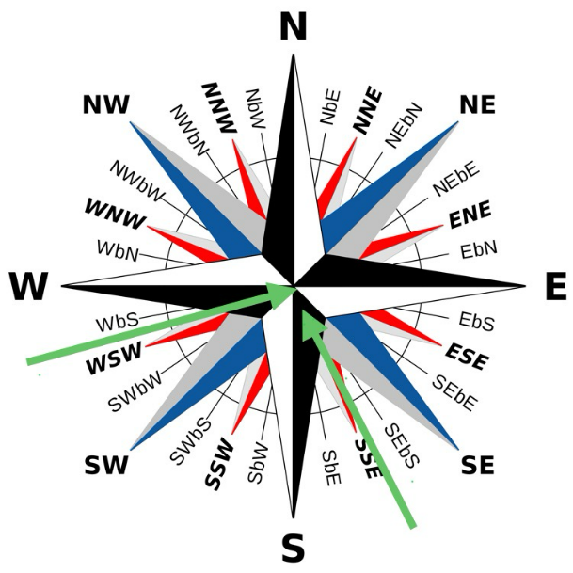
The biggest concern to residents of the Toft Newton parish is the odour that will be released from having up to 270,000 chickens on site, from the production of 2,936 tonnes annually of manure, the dead birds only being removed from the site on average every 6 days, increased transport emissions and from the 76 cleaning days annually where strong chemicals will be used to remove all traces of the previous flock.

We acknowledge that Ammonia levels will be low, however, Ammonia will be being released into the environment.

The wind speed models in the Environment Statement shows that the fastest wind speed will be most likely to come from the south-south east to west-south west directions, meaning that the area most likely to be affected by strong winds is the parish of Toft Newton, especially over some of the neighbouring parishes.

Noise and light pollution:
We note that noise and light pollution are anticipated as being low, with long term flood lights only being used during the cleaning phases (10 days out of every 48 days).

Concern, however, has been raised about the noise generated by eight extractor fans on each building operating constantly, especially when the wind blows in the direction of the Toft Newton parish, therefore carrying the noise to our parish.

Transport:
The provision of five parking spaces for staff and visitors, and on-site roads with turning lanes, along with the 699 - 714 extra tankers, 7.5 tonne lorries and 44 tonnes / 16.5 meter articulated HGVs per year will put significant strain on the local single lane country roads.

The local road network already has pinch points where congestion can be significant.

The transport issues will not just affect the residents of Faldingworth and Spridlington, but will have significant implications for the wider Dunholme and Welton ward, as well impacting upon the wider West Lindsey District, Lincoln City and Lincolnshire County roads network

We note that the Transport Assessment states this area is not particularly a high risk accident area, however, with the addition of an annual anticipated increase in car journeys of 2,190 and 699 - 714 larger vehicles, we are concerned that the accident risk will increase.

Live chickens will be transported to and from the site on day 1, day 30, day 37 of day 38 of a 48 day cycle. Dead chickens will be removed from the site on average every six days, manure will be removed on average every three days.

Infrastructure:
We are concerned about the impact this development would have on the road network, the electricity supply and the local waterways, putting unnecessary pressure on all three.

Conclusion:
While some residents of the Toft Newton parish are not opposed to the development and the Parish Council acknowledges that there are some positives, we believe overall the impact of such a development on the outskirts of our Parish will overall have negative consequences.

It is for the above reasons that we, Toft Newton Parish Council, strongly oppose this proposed development.

I trust that our views will be taken into consideration when making a decision on this application.

We wholly support the objections from Faldingworth Parish Council, Spridlington Parish Council and Skydock.

Should you require any further clarification on our concerns, please do not hesitate to contact me.

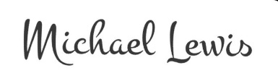
Yours sincerely,

Michael Lewis, Dip Psy (ICS), CertHE (Glouc), FCMI, MIOEE
Parish Council Clerk, Responsible Financial Officer and Proper Officer

